AI LAB EXPERIMENTS AND EXECUTED OUTPUT (5-10)

NAME | GEETIKA T
REG NO | 192511469
COURSE | ARTIFICIAL INTELLIGENCE
COURSE CODE | CSA1701

  - EXPERIMENT NO 6:Write the python program for Vacuum Cleaner problem
AIM:
To write a Python program to solve the Vacuum Cleaner problem using the Simple Reflex Agent approach.
ALGORITHMN:
- Start the program.
- Initialize the two rooms, A and B, as dirty.
- Place the vacuum cleaner in room A.
- Check whether the current room is dirty.
- If the room is dirty, clean it.
- If the current room is clean, move to the other room.
- Repeat the process until both rooms are clean.
- Display the final status of both rooms.
- Stop the program.
PROGRAM:

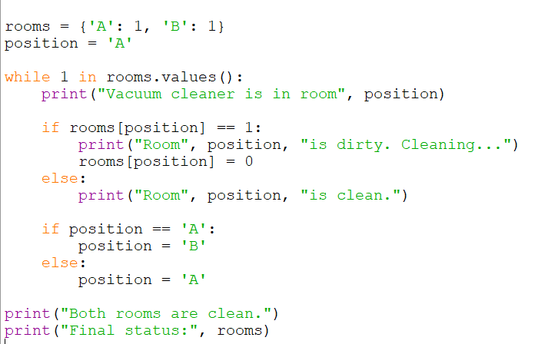

OUTPUT:
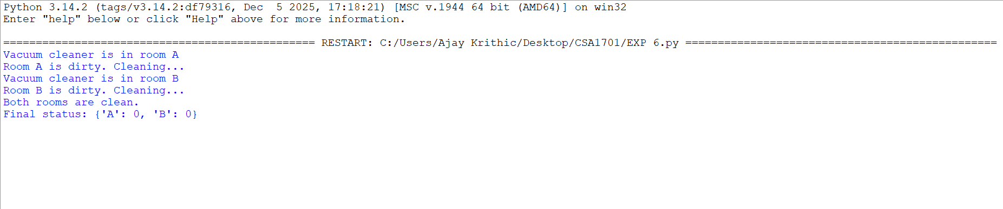

RESULT:
The Vacuum Cleaner problem was successfully solved using the Simple Reflex Agent approach. The program cleans both rooms and displays their final status.

EXPERIMENT NO 7: Write the python program to implement BFS.

AIM:
To write a Python program to implement Breadth First Search (BFS) traversal of a graph.
ALGORITHMN:
- Start the program.
- Represent the graph using an adjacency list.
- Initialize a queue with the starting node.
- Mark the starting node as visited.
- Remove the first node from the queue and display it.
- Add all unvisited adjacent nodes to the queue and mark them as visited.
- Repeat steps 5 and 6 until the queue becomes empty.
- Stop the program.
PROGRAM:
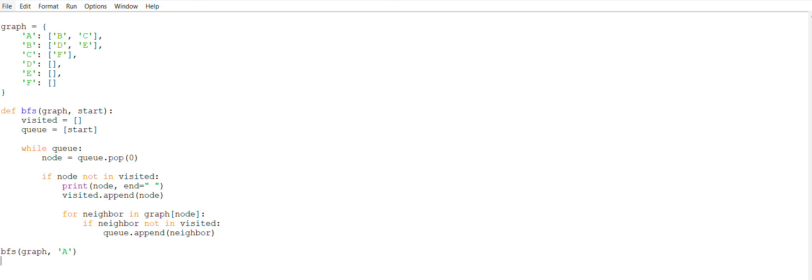
OUTPUT:
RESULT:
The Breadth First Search (BFS) algorithm was successfully implemented to traverse the graph level by level, starting from the given node.

EXPERIMENT NO 8: Write the python program to implement DFS.
AIM:
To write a Python program to implement Depth First Search (DFS) traversal of a graph.
ALGORITHMN:
- Start the program.
- Represent the graph using an adjacency list.
- Initialize an empty list to store visited nodes.
- Start DFS from the given starting node.
- Mark the current node as visited and display it.
- Visit each unvisited adjacent node recursively.
- Continue until all reachable nodes are visited.
- Stop the program.
PROGRAM:
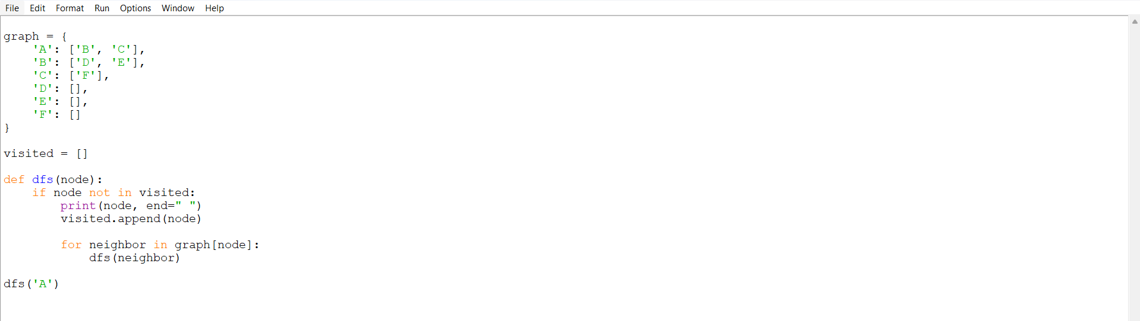

OUTPUT:

RESULT:
The Depth First Search (DFS) algorithm was successfully implemented to traverse the graph by exploring each branch deeply before backtracking.
EXPERIMENT NO 9: Write the python to implement Travelling Salesman Problem

AIM:
To write a Python program to solve the Travelling Salesman Problem (TSP) using the brute-force technique to find the minimum-cost tour.
ALGORITHMN:
- Start the program.
- Define the number of cities and the distance matrix.
- Fix the first city as the starting city.
- Generate all possible routes visiting every other city exactly once.
- Return to the starting city after visiting all cities.
- Calculate the total cost of each route.
- Compare the costs and select the route with the minimum cost.
- Display the optimal route and its total cost.
- Stop the program.
PROGRAM:
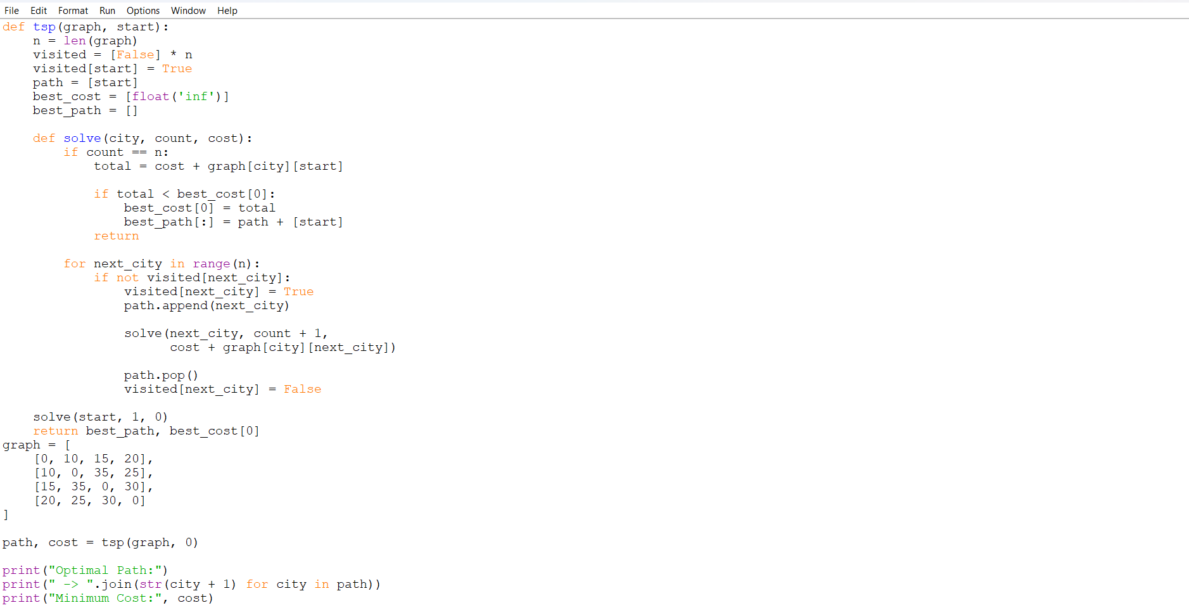
OUTPUT:
RESULT:
The Travelling Salesman Problem was successfully solved using the brute-force technique, and the optimal route with minimum travel cost was obtained.

EXPERIMENT NO 10: Write the python program to implement A" algorithm
AIM:
To write a Python program to implement the A* search algorithm to find the shortest path from the start node to the goal node using a heuristic function.
ALGORITHMN:
- Start the program.
- Define the graph with edge costs and heuristic values for each node.
- Initialize the open list with the start node and the closed list as empty.
- Calculate the evaluation function f(n) = g(n) + h(n).
- Select the node with the lowest f(n) value from the open list.
- If the selected node is the goal node, display the path and stop.
- Otherwise, move the selected node to the closed list.
- Add its unvisited neighboring nodes to the open list and calculate their costs.
- Repeat steps 5 to 8 until the goal is found or the open list becomes empty.
- Stop the program.
PROGRAM:
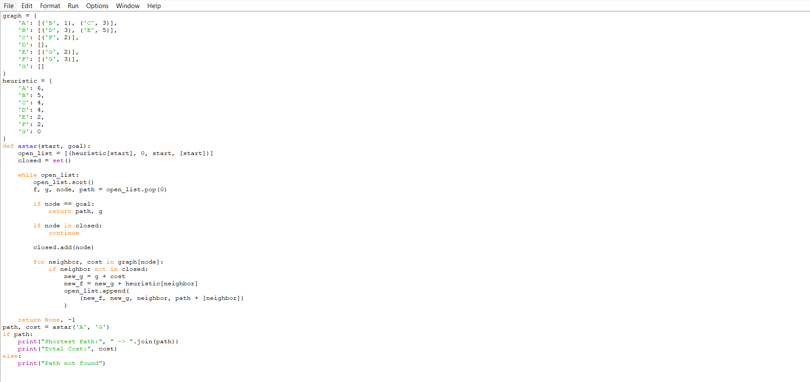
OUTPUT:
RESULT:
The A* search algorithm was successfully implemented to find a path from the start node to the goal node using the evaluation function f(n) = g(n) + h(n).

